**Illustration Research**

Types of Illustrations

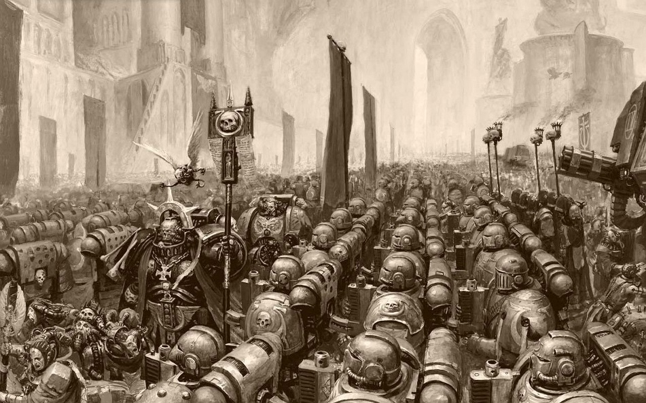This image is from the Warhammer 40k Space Marine codex. This image was probably sketched out to get the overall idea and shape of the image. Then done in Photoshop with a graphics pad, to get the crisp lines in the foreground, but also the faded line in the background, showing depth in the image and the scale of the army within the image. The image in greyscale, shows contrast between the bright buildings in the background and the darker shades and shadows of the army of marines.

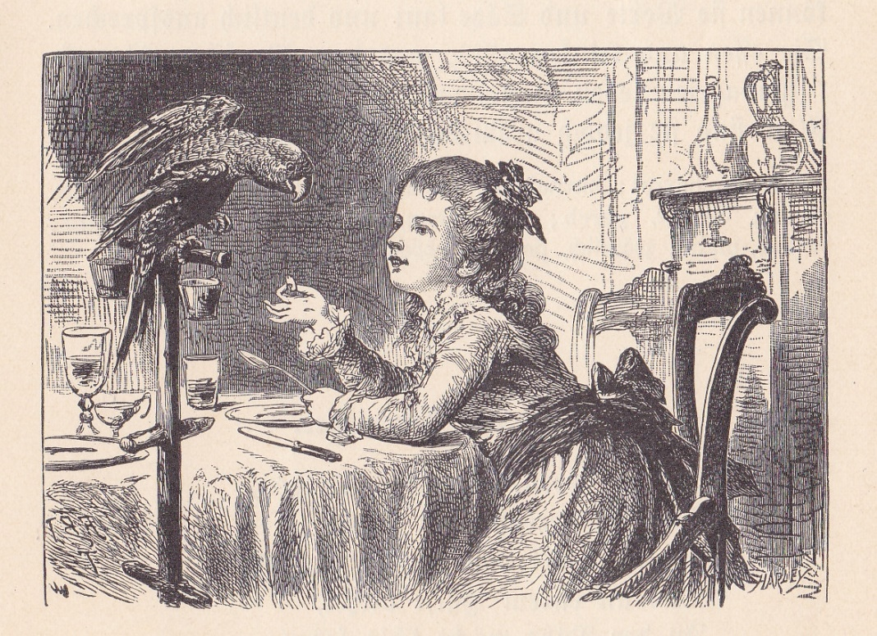

This is an illustration from a book. The illustration looks to be drawn in fine pen and the shading in pen as well. The shading is done with single pen stokes and cross hatching to get the different shade of the shadow. Most of the illustration has pen stokes, except the brightest areas of the image.

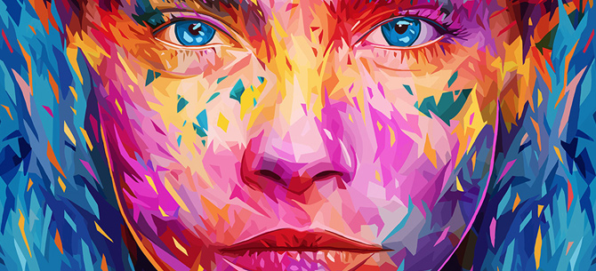This illustration is a modern illustration, this image was probably made using adobe illustrator. I think this illustration was made in illustrator, over Photoshop, because a lot of the shapes that make up the face, have straight lines and sharp edges.

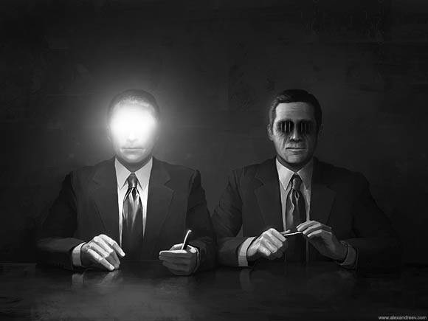

This illustration, is a visual metaphor for good cop, bad cop. So the way this is represented is the good cop has lights for eyes, saying you talk to me and I can help you see the light of outside again. The light also say that the cop is going to be nice to the person.

The bad cop has jail bars for eyes, representing that he is going to be as hard as jail, and that the cop doesn’t mind, the person going to jail and never seeing the light again. I would say that this illustration was done in Photoshop.

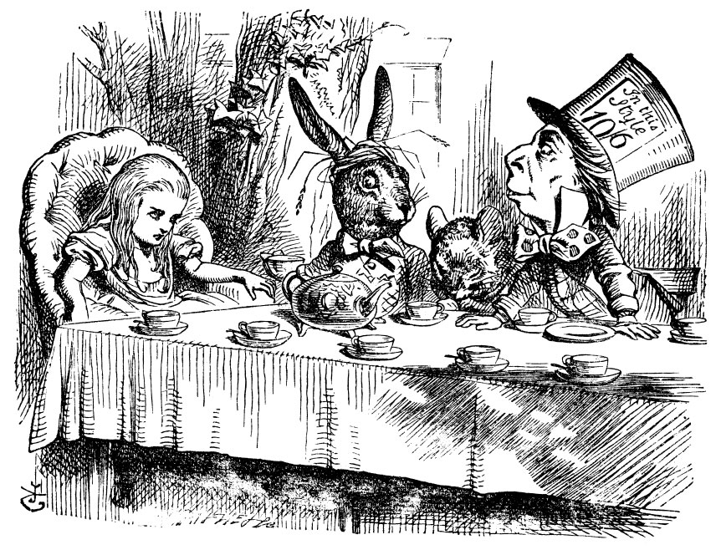

This illustration is from Alice in Wonderland. This is the tea party. This originally done is fine pen with single pen stokes to heavy cross hatching for the shade of the image. This image has been given colour, but the colour isn’t solid colour. The colour is faded, so that you can still see the original pen stokes.

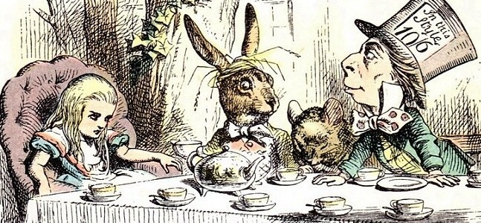

Visual metaphors

Visual metaphors, are where a metaphor is spoken, but through an image/images without a word. They are used in many different ways, but mostly in advertising for products.

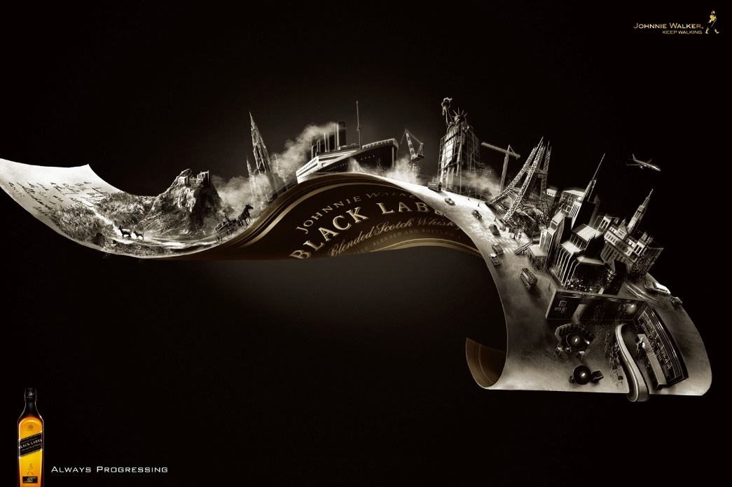This image is advertising Black Label whiskey. The image is showing that the taste and flavour is evolving with time as we have and will continue too. The progress is sat on the label, so we that is wrapped around the bottle, the progress would be in the bottle. The whole piece is in black and white, other than the name, which has a gold tint to it, to draw your eye to it. The progress for on the label isn’t the finished item. The items are still getting built, showing progress.

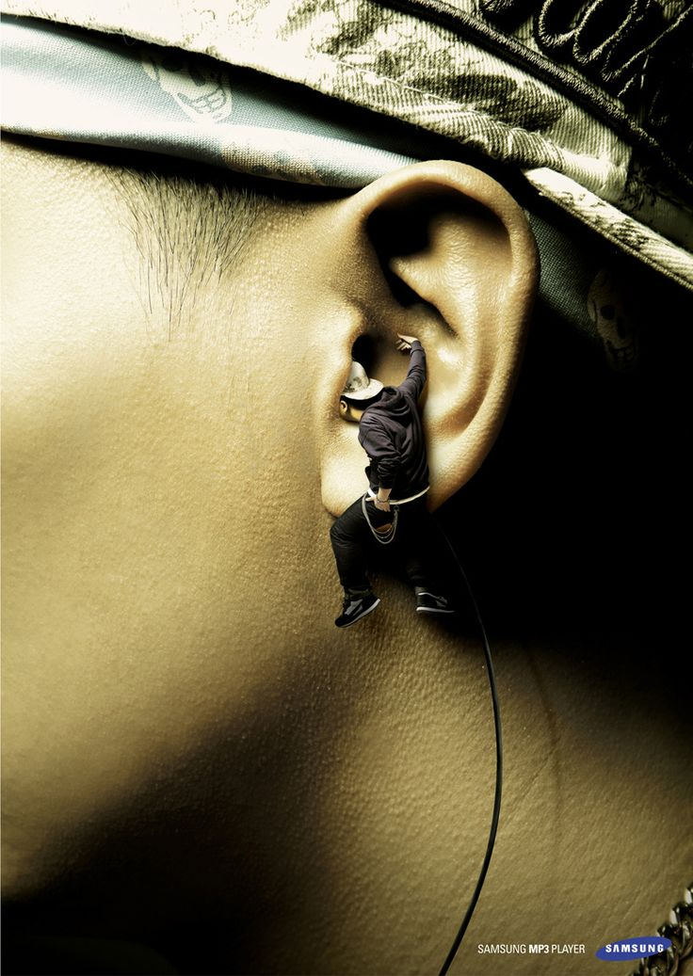This is another advert, but this time it is for Samsung earphones. It’s saying that the sound is so good that it’s like having a mini version of the artist in your ear.

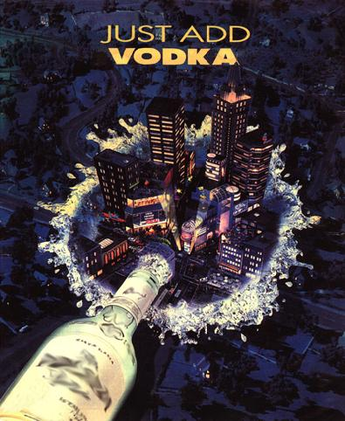

The advert of the vodka. It is saying that your life is dull and boring without this vodka, so add some to your life and it will be bright and colourful and a party. The splash could symbolise water, saying that it will down as easily as water, but on the other hand the size of the splash to the city, it could be a tsunami, so it could also be saying it will hit you a tsunami.

Visual Rhetoric

Visual Rhetoric is how something appeals to the reader. How the colours, logos, symbols are arranged and how we read the image/advert.

Is isn’t an advert, but if this was a advert for something, I think it would be a good one, because when you look at the image you are drawn straight to the eyes of the women, because her blue eyes contrast the yellows, oranges and pinks around her eyes. The colour make me think of the soul of the person and as you are drawn to the eyes, which have been to call, the window to the soul, it fits together with the image.

Composition Rules

Rule of Thirds

The rule of thirds is where you split the image into a 3 by 3 grid equally. You place a main feature on the cross sections or on the lines horizontally or vertically. Placing a main feature at this points catches our eyes more. You can have the grid within a section of the grid.

So in this image the eyes are placed on the vertical lines to draw our eyes to them. Also the bottom of the nose is place on the bottom horizontal line. The placement and the size of the nose also uses the rule of thirds.

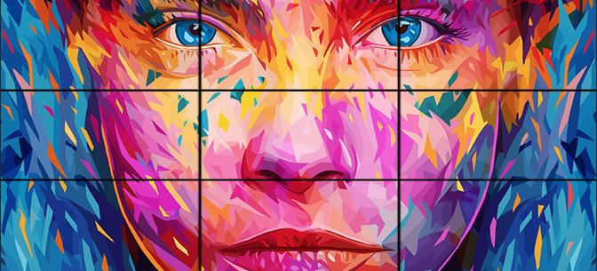

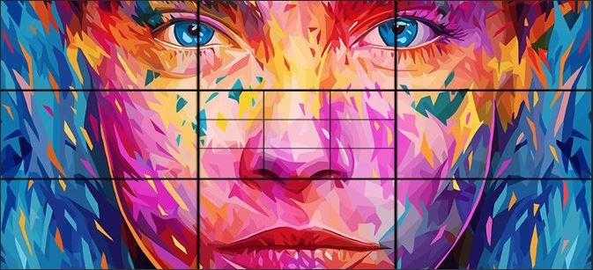

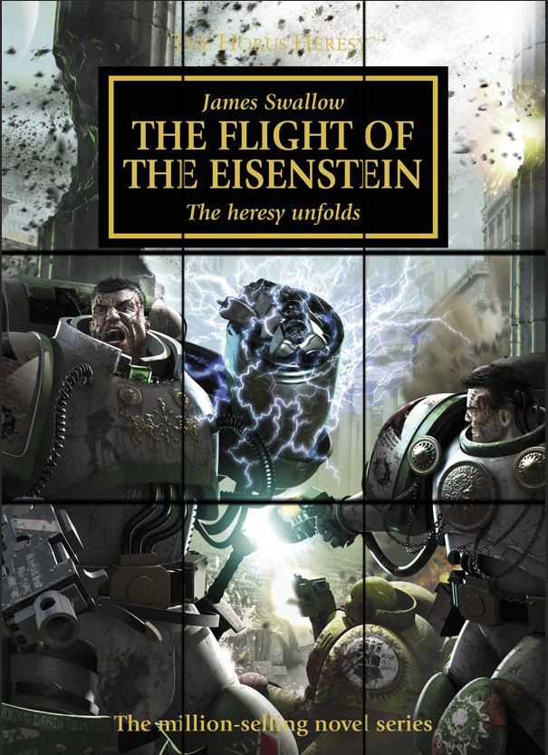This one, they have used the space to place the main features, instead of the lines. They have still used the lines to place the title of the book.

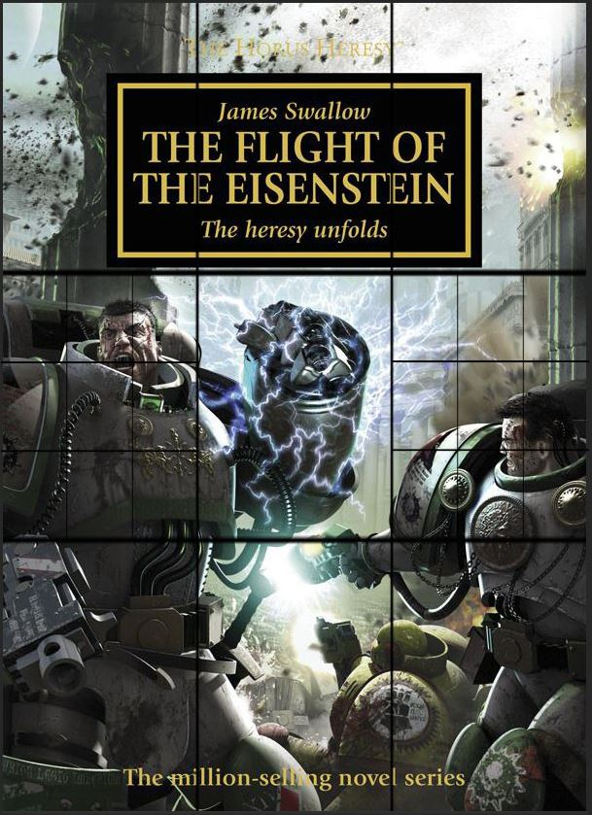

This image does use the rule of thirds, but to see it, you can to use the rule of thirds twice, to see it. So in this case the man’s eye is set upon the line and this mouth is set on one of the cross sections.

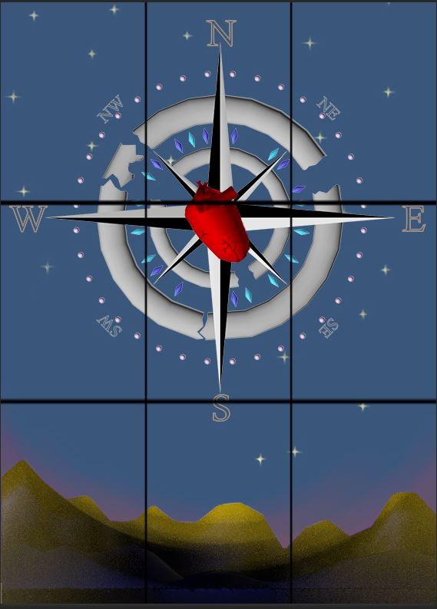

Is my illustration, I have used the rule of thirds, (being truthful, without knowing). The W for west and the E for east, just touch the top horizontal line and the inner circle of the compass fits inside the two vertical lines of the grid.

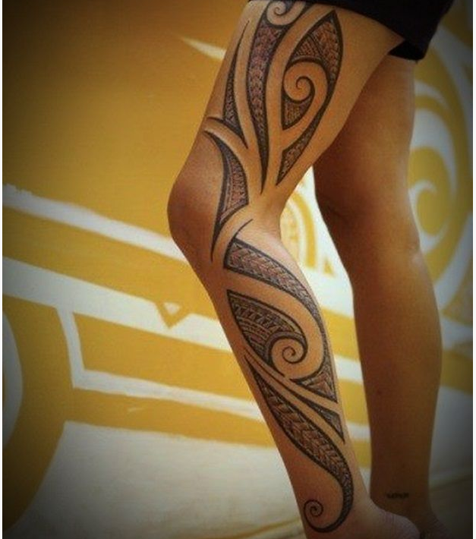

Composition can also include placement. A good example of this is tattoos. As depending on the design the tattoo’s placement needs to flow with the body e.g. a tribal piece going down someone’s leg instead straight down the side of their leg, it might curve over their leg from outside to the inside of their leg while still going down. Or the tribal style may change to flow better with the body.

## 

## Another composition tool is known as the golden ratio, which is 1.618. This can be seen in the Mona Lisa by Leonardo da Vinci.

The way it works is that you add the last two squares together to get the next one e.g. 1,1,2,3,5,8,13,21,34,55,etc…

